**Experiment No :** 13

**Experiment name :** Write a C Program to find reverse of a number .

**Methodology :**

This program takes an integer as input from the user and calculates its reverse by repeatedly extracting the last digit using the modulo operator % and then adding it to the reversed number after shifting the reversed number to the left by one position (multiplying by 10). It continues this process until the original number becomes zero. Finally, it prints the reverse of the input number.

**Flow-Chart :**

Declear ->int n , reverse = 0 , remainder ;

No

**Code :**

Yes

Reminder = n%10;

Reverse = reverse*10+reminder ;

N=n/10

Print reverse

While(n!=0)

scanf("%d",&n);

#include<stdio.h>

int main()

{

int n , reverse = 0 , remainder ;

printf("Enter a number : ");

scanf("%d",&n);

while(n!=0){

remainder = n%10 ;

reverse = reverse*10 +remainder ;

n/=10 ;

}

printf("Reversed number = %d",reverse);

return 0;

}

**Output:**

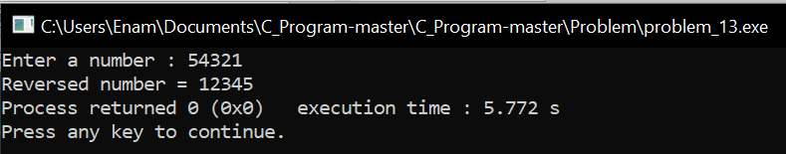

**Result discussion :**

Through this program we can reverse any number. Here the formula we used is that first we reminded the original number that we had and divided it by ten after dividing it by ten. By multiplying our reverse variable by 10 and adding it to the reminder we can reverse a number.